Visual Basic Programs

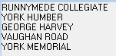

Print "RUNNYMEDE COLLEGIATE"

Print "YORK HUMBER"

Print "GEORGE HARVEY"

Print "VAUGHAN ROAD"

Print "YORK MEMORIAL"

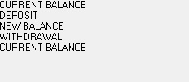

Print "CURRENT BALANCE"

Print "DEPOSIT"

Print "NEW BALANCE"

Print "WITHDRAWAL"

Print "CURRENT BALANCE"

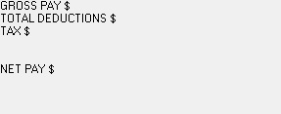

Print "GROSS PAY $"

Print "TOTAL DEDUCTIONS $"

Print "TAX $"

Print ""

Print ""

Print "NET PAY $"

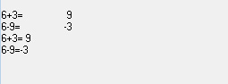Print

Print "6+3=", 6 + 3

Print "6-9=", 6 - 9

Print "6+3="; 6 + 3

Print "6-9="; 6 – 9

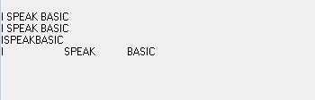

Print "I"; " SPEAK"; " BASIC"

Print "I "; "SPEAK "; "BASIC"

Print "I"; "SPEAK"; "BASIC"

Print "I", "SPEAK", "BASIC"

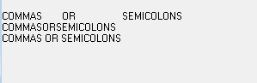Print "COMMAS", "OR", "SEMICOLONS"

Print "COMMAS"; "OR"; "SEMICOLONS"

Print "COMMAS "; "OR "; "SEMICOLONS"

Print

Print "MY",

Print "PROGRAM"

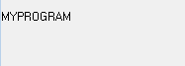

Print

Print "MY";

Print "PROGRAM"

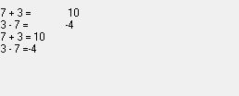

Print

Print "7 + 3 =", 7 + 3

Print "3 - 7 =", 3 - 7

Print "7 + 3 ="; 7 + 3

Print "3 - 7 ="; 3 – 7

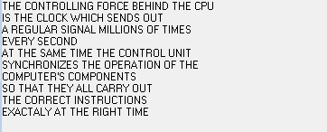Print "THE CONTROLLING FORCE BEHIND THE CPU"

Print "IS THE CLOCK WHICH SENDS OUT"

Print "A REGULAR SIGNAL MILLIONS OF TIMES"

Print "EVERY SECOND"

Print "AT THE SAME TIME THE CONTROL UNIT"

Print "SYNCHRONIZES THE OPERATION OF THE"

Print "COMPUTER'S COMPONENTS"

Print "SO THAT THEY ALL CARRY OUT"

Print "THE CORRECT INSTRUCTIONS"

Print "EXACTALY AT THE RIGHT TIME"

C = 400

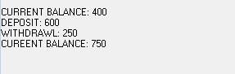D = 600

W = 250

Print

Print "CURRENT BALANCE:"; C

Print "DEPOSIT:"; D

C = C + D

Print "WITHDRAWL:"; W

C = C - W

Print "CUREENT BALANCE:"; C

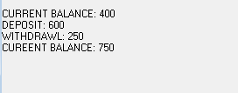A = 10

B = 20

C = 35

D = 6.5

C = B

D = A

Z = C

X = C + D + Z

Print A; B; C; D; Z; X

A = 35

B = 15

C = 31

D = 81

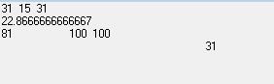E = 26

F = 100

A = F

A = C

E = F

Z = (A + C + D + F + E) / B

Print A; B; C

Print Z

Print D, E; F;

Print

Print , , , A;

Print